**15BCE0517**

**M.S.SANJAY**

**L3+L4**

**DATA MINING LAB**

**CLASSIFICATION AND APRIORI:**

**Mushroom dataset from kaggle:**

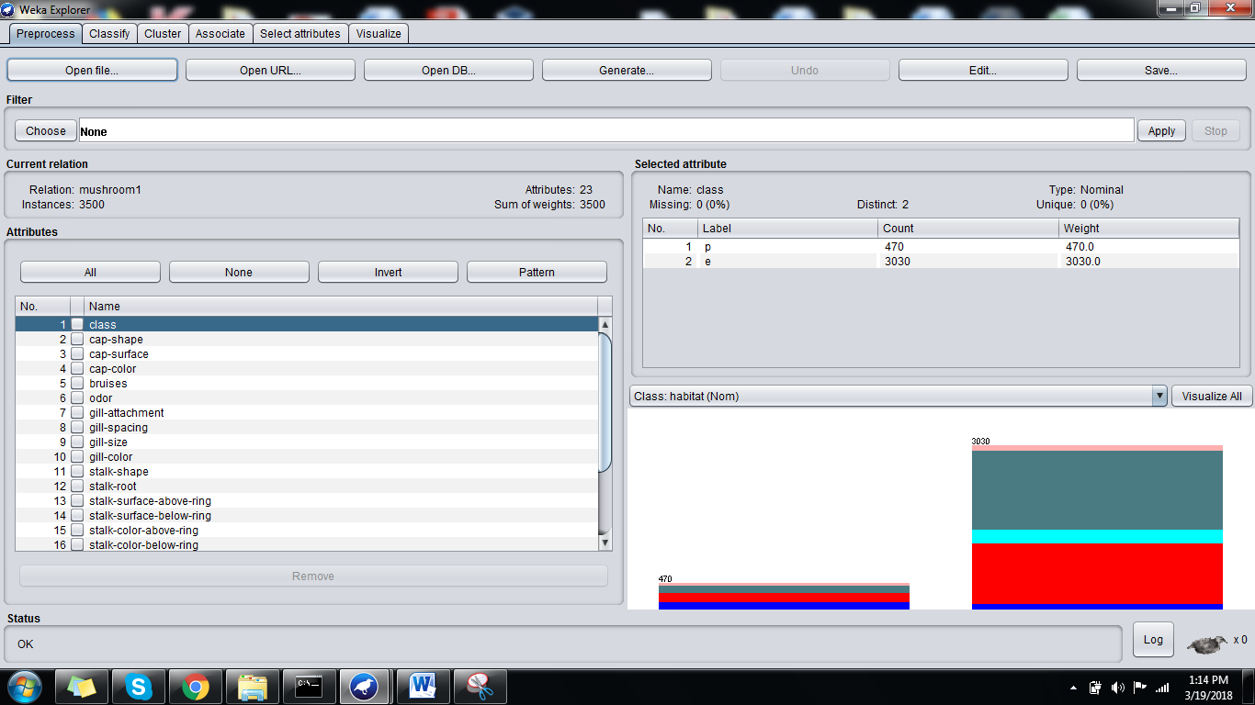

**RANDOM FOREST:**

=== Run information ===

Scheme: weka.classifiers.trees.RandomForest -P 100 -I 100 -num-slots 1 -K 0 -M 1.0 -V 0.001 -S 1

Relation: mushroom1

Instances: 3500

Attributes: 23

class

cap-shape

cap-surface

cap-color

bruises

odor

gill-attachment

gill-spacing

gill-size

gill-color

stalk-shape

stalk-root

stalk-surface-above-ring

stalk-surface-below-ring

stalk-color-above-ring

stalk-color-below-ring

veil-type

veil-color

ring-number

ring-type

spore-print-color

population

habitat

Test mode: 10-fold cross-validation

=== Classifier model (full training set) ===

RandomForest

Bagging with 100 iterations and base learner

weka.classifiers.trees.RandomTree -K 0 -M 1.0 -V 0.001 -S 1 -do-not-check-capabilities

Time taken to build model: 1.55 seconds

=== Stratified cross-validation ===

=== Summary ===

Correctly Classified Instances 2475 70.7143 %

Incorrectly Classified Instances 1025 29.2857 %

Kappa statistic 0.5478

Mean absolute error 0.0972

Root mean squared error 0.2768

Relative absolute error 37.5346 %

Root relative squared error 76.9479 %

Total Number of Instances 3500

=== Detailed Accuracy By Class ===

TP Rate FP Rate Precision Recall F-Measure MCC ROC Area PRC Area Class

0.438 0.037 0.445 0.438 0.441 0.404 0.978 0.742 u

0.618 0.223 0.616 0.618 0.617 0.395 0.905 0.863 g

0.039 0.075 0.040 0.039 0.039 -0.036 0.921 0.308 m

0.978 0.014 0.983 0.978 0.980 0.964 0.999 0.999 d

0.105 0.041 0.097 0.105 0.101 0.061 0.955 0.298 p

Weighted Avg. 0.707 0.098 0.709 0.707 0.708 0.609 0.956 0.854

=== Confusion Matrix ===

a b c d e <-- classified as

98 126 0 0 0 | a = u

122 794 242 10 116 | b = g

0 246 10 0 0 | c = m

0 12 0 1558 23 | d = d

0 111 0 17 15 | e = p

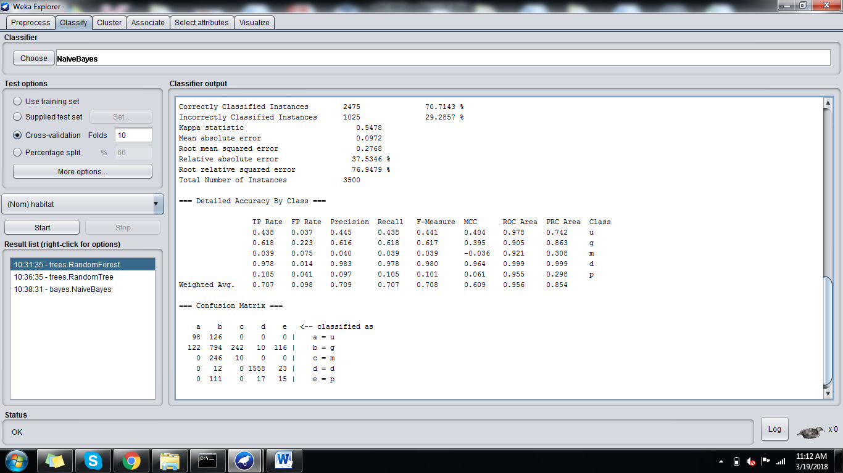

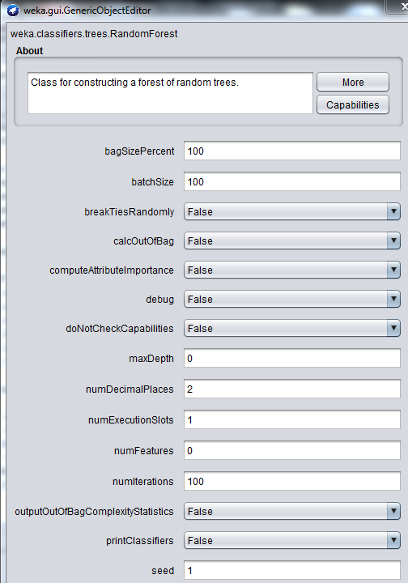

**RANDOM TREE:**

=== Run information ===

Scheme: weka.classifiers.trees.RandomTree -K 0 -M 1.0 -V 0.001 -S 1

Relation: mushroom1

Instances: 3500

Attributes: 23

class

cap-shape

cap-surface

cap-color

bruises

odor

gill-attachment

gill-spacing

gill-size

gill-color

stalk-shape

stalk-root

stalk-surface-above-ring

stalk-surface-below-ring

stalk-color-above-ring

stalk-color-below-ring

veil-type

veil-color

ring-number

ring-type

spore-print-color

population

habitat

Test mode: 10-fold cross-validation

=== Classifier model (full training set) ===

RandomTree

==========

stalk-root = e

| ring-type = p

| | cap-shape = x

| | | bruises = t : u (128/64)

| | | bruises = f : u (32/0)

| | cap-shape = b : u (0/0)

| | cap-shape = s : u (32/0)

| | cap-shape = f

| | | bruises = t : u (128/64)

| | | bruises = f : u (32/0)

| ring-type = e : g (768/0)

| ring-type = l : u (0/0)

stalk-root = c : g (512/256)

stalk-root = b

| spore-print-color = k : d (734/0)

| spore-print-color = n : d (776/0)

| spore-print-color = u : d (48/0)

| spore-print-color = h

| | cap-shape = x

| | | cap-surface = s : u (0/0)

| | | cap-surface = y

| | | | stalk-color-below-ring = w : u (0/0)

| | | | stalk-color-below-ring = p

| | | | | population = s : u (0/0)

| | | | | population = n : u (0/0)

| | | | | population = a : u (0/0)

| | | | | population = v

| | | | | | cap-color = n : u (0/0)

| | | | | | cap-color = y : g (1/0)

| | | | | | cap-color = w : u (0/0)

| | | | | | cap-color = g

| | | | | | | gill-color = k : u (0/0)

| | | | | | | gill-color = n : u (0/0)

| | | | | | | gill-color = g : g (1/0)

| | | | | | | gill-color = p : p (1/0)

| | | | | | | gill-color = w : u (0/0)

| | | | | | | gill-color = h : u (0/0)

| | | | | | | gill-color = u : u (0/0)

| | | | | | cap-color = e : u (0/0)

| | | | | | cap-color = p : u (0/0)

| | | | | population = y : d (2/0)

| | | | stalk-color-below-ring = g : u (0/0)

| | | | stalk-color-below-ring = b : p (1/0)

| | | | stalk-color-below-ring = n

| | | | | gill-color = k : u (0/0)

| | | | | gill-color = n : u (0/0)

| | | | | gill-color = g : g (2/0)

| | | | | gill-color = p : u (0/0)

| | | | | gill-color = w : u (0/0)

| | | | | gill-color = h : p (1/0)

| | | | | gill-color = u : u (0/0)

| | | cap-surface = f

| | | | stalk-color-below-ring = w : u (0/0)

| | | | stalk-color-below-ring = p

| | | | | stalk-color-above-ring = w : u (0/0)

| | | | | stalk-color-above-ring = g : u (0/0)

| | | | | stalk-color-above-ring = p

| | | | | | population = s : u (0/0)

| | | | | | population = n : u (0/0)

| | | | | | population = a : u (0/0)

| | | | | | population = v

| | | | | | | gill-color = k : u (0/0)

| | | | | | | gill-color = n : u (0/0)

| | | | | | | gill-color = g : p (1/0)

| | | | | | | gill-color = p : g (2/1)

| | | | | | | gill-color = w : u (0/0)

| | | | | | | gill-color = h : g (2/1)

| | | | | | | gill-color = u : u (0/0)

| | | | | | population = y

| | | | | | | gill-color = k : u (0/0)

| | | | | | | gill-color = n : u (0/0)

| | | | | | | gill-color = g : g (2/1)

| | | | | | | gill-color = p : u (0/0)

| | | | | | | gill-color = w : u (0/0)

| | | | | | | gill-color = h : g (3/2)

| | | | | | | gill-color = u : u (0/0)

| | | | | stalk-color-above-ring = n

| | | | | | gill-color = k : u (0/0)

| | | | | | gill-color = n : u (0/0)

| | | | | | gill-color = g

| | | | | | | population = s : u (0/0)

| | | | | | | population = n : u (0/0)

| | | | | | | population = a : u (0/0)

| | | | | | | population = v : p (1/0)

| | | | | | | population = y : g (2/1)

| | | | | | gill-color = p

| | | | | | | population = s : u (0/0)

| | | | | | | population = n : u (0/0)

| | | | | | | population = a : u (0/0)

| | | | | | | population = v : g (2/1)

| | | | | | | population = y : g (2/1)

| | | | | | gill-color = w : u (0/0)

| | | | | | gill-color = h

| | | | | | | population = s : u (0/0)

| | | | | | | population = n : u (0/0)

| | | | | | | population = a : u (0/0)

| | | | | | | population = v : g (2/1)

| | | | | | | population = y : d (2/1)

| | | | | | gill-color = u : u (0/0)

| | | | | stalk-color-above-ring = b

| | | | | | population = s : u (0/0)

| | | | | | population = n : u (0/0)

| | | | | | population = a : u (0/0)

| | | | | | population = v

| | | | | | | gill-color = k : u (0/0)

| | | | | | | gill-color = n : u (0/0)

| | | | | | | gill-color = g : g (2/1)

| | | | | | | gill-color = p : g (2/1)

| | | | | | | gill-color = w : u (0/0)

| | | | | | | gill-color = h : p (1/0)

| | | | | | | gill-color = u : u (0/0)

| | | | | | population = y

| | | | | | | gill-color = k : u (0/0)

| | | | | | | gill-color = n : u (0/0)

| | | | | | | gill-color = g : g (3/2)

| | | | | | | gill-color = p : g (2/1)

| | | | | | | gill-color = w : u (0/0)

| | | | | | | gill-color = h : g (1/0)

| | | | | | | gill-color = u : u (0/0)

| | | | stalk-color-below-ring = g : u (0/0)

| | | | stalk-color-below-ring = b

| | | | | stalk-color-above-ring = w : u (0/0)

| | | | | stalk-color-above-ring = g : u (0/0)

| | | | | stalk-color-above-ring = p

| | | | | | gill-color = k : u (0/0)

| | | | | | gill-color = n : u (0/0)

| | | | | | gill-color = g

| | | | | | | population = s : u (0/0)

| | | | | | | population = n : u (0/0)

| | | | | | | population = a : u (0/0)

| | | | | | | population = v : p (1/0)

| | | | | | | population = y : d (2/1)

| | | | | | gill-color = p

| | | | | | | population = s : u (0/0)

| | | | | | | population = n : u (0/0)

| | | | | | | population = a : u (0/0)

| | | | | | | population = v : g (1/0)

| | | | | | | population = y

| | | | | | | | cap-color = n : u (0/0)

| | | | | | | | cap-color = y : g (1/0)

| | | | | | | | cap-color = w : u (0/0)

| | | | | | | | cap-color = g : g (3/2)

| | | | | | | | cap-color = e : u (0/0)

| | | | | | | | cap-color = p : u (0/0)

| | | | | | gill-color = w : u (0/0)

| | | | | | gill-color = h : d (4/2)

| | | | | | gill-color = u : u (0/0)

| | | | | stalk-color-above-ring = n

| | | | | | gill-color = k : u (0/0)

| | | | | | gill-color = n : u (0/0)

| | | | | | gill-color = g

| | | | | | | cap-color = n : u (0/0)

| | | | | | | cap-color = y : d (1/0)

| | | | | | | cap-color = w : u (0/0)

| | | | | | | cap-color = g

| | | | | | | | population = s : u (0/0)

| | | | | | | | population = n : u (0/0)

| | | | | | | | population = a : u (0/0)

| | | | | | | | population = v : p (1/0)

| | | | | | | | population = y : d (2/1)

| | | | | | | cap-color = e : u (0/0)

| | | | | | | cap-color = p : u (0/0)

| | | | | | gill-color = p

| | | | | | | population = s : u (0/0)

| | | | | | | population = n : u (0/0)

| | | | | | | population = a : u (0/0)

| | | | | | | population = v

| | | | | | | | cap-color = n : u (0/0)

| | | | | | | | cap-color = y : p (1/0)

| | | | | | | | cap-color = w : u (0/0)

| | | | | | | | cap-color = g : g (2/1)

| | | | | | | | cap-color = e : u (0/0)

| | | | | | | | cap-color = p : u (0/0)

| | | | | | | population = y : d (2/1)

| | | | | | gill-color = w : u (0/0)

| | | | | | gill-color = h : g (4/2)

| | | | | | gill-color = u : u (0/0)

| | | | | stalk-color-above-ring = b

| | | | | | gill-color = k : u (0/0)

| | | | | | gill-color = n : u (0/0)

| | | | | | gill-color = g

| | | | | | | population = s : u (0/0)

| | | | | | | population = n : u (0/0)

| | | | | | | population = a : u (0/0)

| | | | | | | population = v : d (2/1)

| | | | | | | population = y : g (3/2)

| | | | | | gill-color = p : g (2/0)

| | | | | | gill-color = w : u (0/0)

| | | | | | gill-color = h

| | | | | | | population = s : u (0/0)

| | | | | | | population = n : u (0/0)

| | | | | | | population = a : u (0/0)

| | | | | | | population = v : d (1/0)

| | | | | | | population = y : g (1/0)

| | | | | | gill-color = u : u (0/0)

| | | | stalk-color-below-ring = n

| | | | | stalk-color-above-ring = w : u (0/0)

| | | | | stalk-color-above-ring = g : u (0/0)

| | | | | stalk-color-above-ring = p

| | | | | | population = s : u (0/0)

| | | | | | population = n : u (0/0)

| | | | | | population = a : u (0/0)

| | | | | | population = v

| | | | | | | gill-color = k : u (0/0)

| | | | | | | gill-color = n : u (0/0)

| | | | | | | gill-color = g : g (3/2)

| | | | | | | gill-color = p : u (0/0)

| | | | | | | gill-color = w : u (0/0)

| | | | | | | gill-color = h : g (1/0)

| | | | | | | gill-color = u : u (0/0)

| | | | | | population = y

| | | | | | | gill-color = k : u (0/0)

| | | | | | | gill-color = n : u (0/0)

| | | | | | | gill-color = g : g (1/0)

| | | | | | | gill-color = p : d (2/1)

| | | | | | | gill-color = w : u (0/0)

| | | | | | | gill-color = h : d (2/1)

| | | | | | | gill-color = u : u (0/0)

| | | | | stalk-color-above-ring = n

| | | | | | cap-color = n : u (0/0)

| | | | | | cap-color = y : p (2/0)

| | | | | | cap-color = w : u (0/0)

| | | | | | cap-color = g

| | | | | | | gill-color = k : u (0/0)

| | | | | | | gill-color = n : u (0/0)

| | | | | | | gill-color = g

| | | | | | | | population = s : u (0/0)

| | | | | | | | population = n : u (0/0)

| | | | | | | | population = a : u (0/0)

| | | | | | | | population = v : d (2/1)

| | | | | | | | population = y : d (1/0)

| | | | | | | gill-color = p : d (4/2)

| | | | | | | gill-color = w : u (0/0)

| | | | | | | gill-color = h

| | | | | | | | population = s : u (0/0)

| | | | | | | | population = n : u (0/0)

| | | | | | | | population = a : u (0/0)

| | | | | | | | population = v : g (1/0)

| | | | | | | | population = y : g (2/1)

| | | | | | | gill-color = u : u (0/0)

| | | | | | cap-color = e : u (0/0)

| | | | | | cap-color = p : u (0/0)

| | | | | stalk-color-above-ring = b

| | | | | | gill-color = k : u (0/0)

| | | | | | gill-color = n : u (0/0)

| | | | | | gill-color = g : g (4/2)

| | | | | | gill-color = p

| | | | | | | population = s : u (0/0)

| | | | | | | population = n : u (0/0)

| | | | | | | population = a : u (0/0)

| | | | | | | population = v : p (1/0)

| | | | | | | population = y : d (1/0)

| | | | | | gill-color = w : u (0/0)

| | | | | | gill-color = h

| | | | | | | population = s : u (0/0)

| | | | | | | population = n : u (0/0)

| | | | | | | population = a : u (0/0)

| | | | | | | population = v : g (2/1)

| | | | | | | population = y : g (3/2)

| | | | | | gill-color = u : u (0/0)

| | cap-shape = b : u (0/0)

| | cap-shape = s : u (0/0)

| | cap-shape = f

| | | cap-color = n : u (0/0)

| | | cap-color = y

| | | | stalk-color-below-ring = w : u (0/0)

| | | | stalk-color-below-ring = p : d (1/0)

| | | | stalk-color-below-ring = g : u (0/0)

| | | | stalk-color-below-ring = b : u (0/0)

| | | | stalk-color-below-ring = n

| | | | | stalk-color-above-ring = w : u (0/0)

| | | | | stalk-color-above-ring = g : u (0/0)

| | | | | stalk-color-above-ring = p : u (0/0)

| | | | | stalk-color-above-ring = n : p (1/0)

| | | | | stalk-color-above-ring = b

| | | | | | gill-color = k : u (0/0)

| | | | | | gill-color = n : u (0/0)

| | | | | | gill-color = g : p (1/0)

| | | | | | gill-color = p : d (1/0)

| | | | | | gill-color = w : u (0/0)

| | | | | | gill-color = h : u (0/0)

| | | | | | gill-color = u : u (0/0)

| | | cap-color = w : u (0/0)

| | | cap-color = g

| | | | population = s : u (0/0)

| | | | population = n : u (0/0)

| | | | population = a : u (0/0)

| | | | population = v

| | | | | stalk-color-above-ring = w : u (0/0)

| | | | | stalk-color-above-ring = g : u (0/0)

| | | | | stalk-color-above-ring = p : p (1/0)

| | | | | stalk-color-above-ring = n : d (1/0)

| | | | | stalk-color-above-ring = b : p (1/0)

| | | | population = y

| | | | | cap-surface = s : u (0/0)

| | | | | cap-surface = y

| | | | | | stalk-color-below-ring = w : u (0/0)

| | | | | | stalk-color-below-ring = p : p (1/0)

| | | | | | stalk-color-below-ring = g : u (0/0)

| | | | | | stalk-color-below-ring = b : u (0/0)

| | | | | | stalk-color-below-ring = n : d (1/0)

| | | | | cap-surface = f : p (2/0)

| | | cap-color = e : u (0/0)

| | | cap-color = p : u (0/0)

stalk-root = r : g (192/96)

Size of the tree : 306

Time taken to build model: 0.01 seconds

=== Stratified cross-validation ===

=== Summary ===

Correctly Classified Instances 2475 70.7143 %

Incorrectly Classified Instances 1025 29.2857 %

Kappa statistic 0.5461

Mean absolute error 0.1129

Root mean squared error 0.3277

Relative absolute error 43.5943 %

Root relative squared error 91.0975 %

Total Number of Instances 3500

=== Detailed Accuracy By Class ===

TP Rate FP Rate Precision Recall F-Measure MCC ROC Area PRC Area Class

0.455 0.038 0.447 0.455 0.451 0.413 0.737 0.269 u

0.626 0.230 0.612 0.626 0.619 0.395 0.725 0.554 g

0.008 0.072 0.008 0.008 0.008 -0.067 0.559 0.084 m

0.979 0.015 0.982 0.979 0.980 0.964 0.985 0.978 d

0.056 0.038 0.059 0.056 0.058 0.019 0.566 0.053 p

Weighted Avg. 0.707 0.100 0.703 0.707 0.705 0.606 0.826 0.674

=== Confusion Matrix ===

a b c d e <-- classified as

102 122 0 0 0 | a = u

126 804 234 13 107 | b = g

0 254 2 0 0 | c = m

0 14 0 1559 20 | d = d

0 119 0 16 8 | e = p

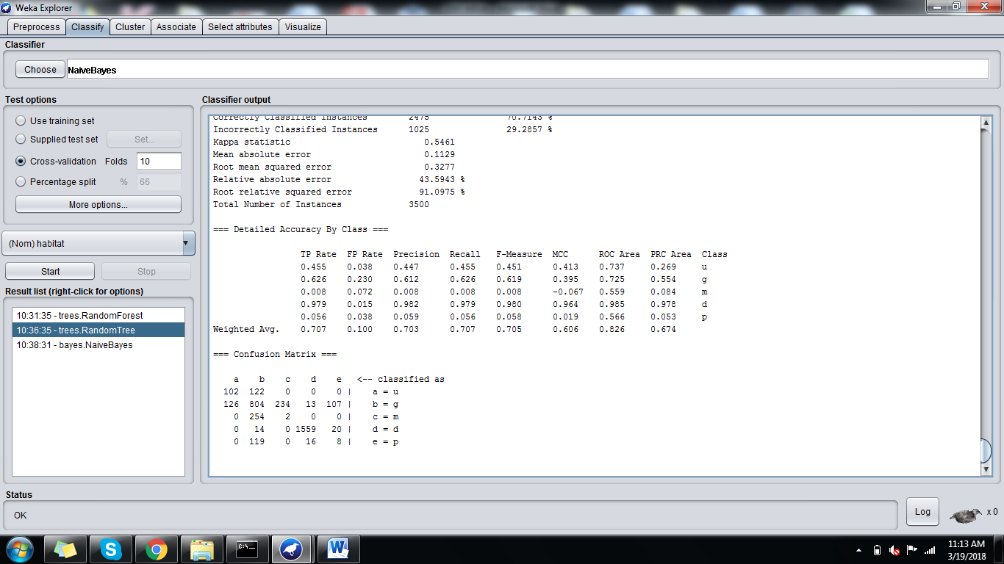

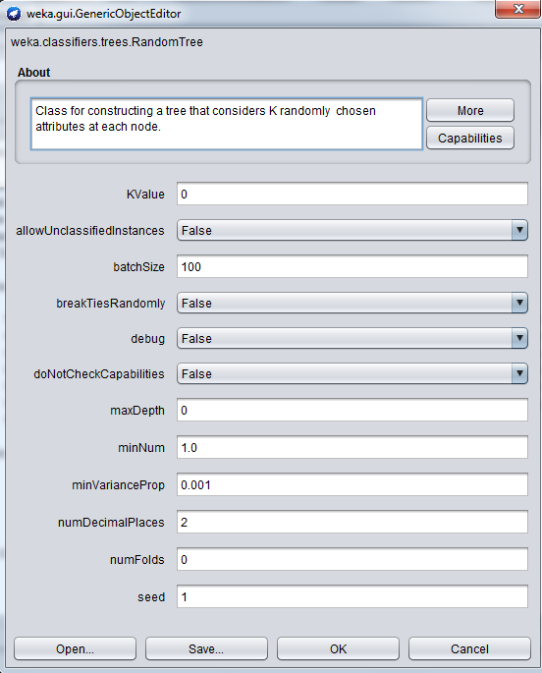

**NAÏVE BAYES:**

=== Run information ===

Scheme: weka.classifiers.bayes.NaiveBayes

Relation: mushroom1

Instances: 3500

Attributes: 23

class

cap-shape

cap-surface

cap-color

bruises

odor

gill-attachment

gill-spacing

gill-size

gill-color

stalk-shape

stalk-root

stalk-surface-above-ring

stalk-surface-below-ring

stalk-color-above-ring

stalk-color-below-ring

veil-type

veil-color

ring-number

ring-type

spore-print-color

population

habitat

Test mode: 10-fold cross-validation

=== Classifier model (full training set) ===

Naive Bayes Classifier

Class

Attribute u g m d p

(0.06) (0.37) (0.07) (0.45) (0.04)

==============================================================

class

p 129.0 165.0 1.0 132.0 48.0

e 97.0 1121.0 257.0 1463.0 97.0

[total] 226.0 1286.0 258.0 1595.0 145.0

cap-shape

x 97.0 661.0 129.0 997.0 89.0

b 1.0 129.0 129.0 1.0 1.0

s 33.0 1.0 1.0 1.0 1.0

f 97.0 497.0 1.0 598.0 56.0

[total] 228.0 1288.0 260.0 1597.0 147.0

cap-surface

s 65.0 577.0 129.0 97.0 1.0

y 65.0 293.0 129.0 641.0 101.0

f 97.0 417.0 1.0 858.0 44.0

[total] 227.0 1287.0 259.0 1596.0 146.0

cap-color

n 113.0 369.0 1.0 488.0 49.0

y 1.0 181.0 129.0 53.0 56.0

w 65.0 449.0 129.0 82.0 1.0

g 49.0 289.0 1.0 524.0 41.0

e 1.0 1.0 1.0 417.0 1.0

p 1.0 1.0 1.0 35.0 1.0

[total] 230.0 1290.0 262.0 1599.0 149.0

bruises

t 129.0 481.0 257.0 1463.0 97.0

f 97.0 805.0 1.0 132.0 48.0

[total] 226.0 1286.0 258.0 1595.0 145.0

odor

p 129.0 129.0 1.0 1.0 1.0

a 1.0 177.0 129.0 49.0 49.0

l 1.0 177.0 129.0 49.0 49.0

n 97.0 769.0 1.0 1367.0 1.0

f 1.0 37.0 1.0 36.0 48.0

c 1.0 1.0 1.0 97.0 1.0

[total] 230.0 1290.0 262.0 1599.0 149.0

gill-attachment

f 225.0 1285.0 257.0 1594.0 144.0

[total] 225.0 1285.0 257.0 1594.0 144.0

gill-spacing

c 225.0 517.0 257.0 1444.0 144.0

w 1.0 769.0 1.0 151.0 1.0

[total] 226.0 1286.0 258.0 1595.0 145.0

gill-size

n 225.0 129.0 1.0 193.0 1.0

b 1.0 1157.0 257.0 1402.0 144.0

[total] 226.0 1286.0 258.0 1595.0 145.0

gill-color

k 57.0 289.0 65.0 1.0 1.0

n 57.0 321.0 65.0 397.0 33.0

g 25.0 77.0 65.0 40.0 20.0

p 57.0 269.0 1.0 422.0 45.0

w 33.0 129.0 65.0 367.0 33.0

h 1.0 205.0 1.0 12.0 17.0

u 1.0 1.0 1.0 361.0 1.0

[total] 231.0 1291.0 263.0 1600.0 150.0

stalk-shape

e 225.0 517.0 257.0 132.0 144.0

t 1.0 769.0 1.0 1463.0 1.0

[total] 226.0 1286.0 258.0 1595.0 145.0

stalk-root

e 225.0 897.0 1.0 1.0 1.0

c 1.0 257.0 257.0 1.0 1.0

b 1.0 37.0 1.0 1594.0 48.0

r 1.0 97.0 1.0 1.0 97.0

[total] 228.0 1288.0 260.0 1597.0 147.0

stalk-surface-above-ring

s 225.0 865.0 257.0 1559.0 97.0

f 1.0 385.0 1.0 1.0 1.0

k 1.0 37.0 1.0 36.0 48.0

[total] 227.0 1287.0 259.0 1596.0 146.0

stalk-surface-below-ring

s 225.0 769.0 257.0 1559.0 1.0

f 1.0 385.0 1.0 1.0 1.0

y 1.0 97.0 1.0 1.0 97.0

k 1.0 37.0 1.0 36.0 48.0

[total] 228.0 1288.0 260.0 1597.0 147.0

stalk-color-above-ring

w 225.0 1249.0 257.0 647.0 97.0

g 1.0 1.0 1.0 458.0 1.0

p 1.0 12.0 1.0 467.0 16.0

n 1.0 11.0 1.0 13.0 22.0

b 1.0 16.0 1.0 13.0 12.0

[total] 229.0 1289.0 261.0 1598.0 148.0

stalk-color-below-ring

w 225.0 1249.0 257.0 636.0 97.0

p 1.0 16.0 1.0 470.0 15.0

g 1.0 1.0 1.0 466.0 1.0

b 1.0 11.0 1.0 11.0 19.0

n 1.0 12.0 1.0 15.0 16.0

[total] 229.0 1289.0 261.0 1598.0 148.0

veil-type

p 225.0 1285.0 257.0 1594.0 144.0

[total] 225.0 1285.0 257.0 1594.0 144.0

veil-color

w 225.0 1285.0 257.0 1594.0 144.0

[total] 225.0 1285.0 257.0 1594.0 144.0

ring-number

o 225.0 1285.0 257.0 1594.0 144.0

[total] 225.0 1285.0 257.0 1594.0 144.0

ring-type

p 225.0 481.0 257.0 1559.0 97.0

e 1.0 769.0 1.0 1.0 1.0

l 1.0 37.0 1.0 36.0 48.0

[total] 227.0 1287.0 259.0 1596.0 146.0

spore-print-color

k 113.0 625.0 129.0 735.0 49.0

n 113.0 625.0 129.0 777.0 49.0

u 1.0 1.0 1.0 49.0 1.0

h 1.0 37.0 1.0 36.0 48.0

[total] 228.0 1288.0 260.0 1597.0 147.0

population

s 65.0 625.0 129.0 53.0 49.0

n 1.0 129.0 129.0 1.0 1.0

a 1.0 385.0 1.0 1.0 1.0

v 113.0 83.0 1.0 835.0 26.0

y 49.0 67.0 1.0 708.0 71.0

[total] 229.0 1289.0 261.0 1598.0 148.0

Time taken to build model: 0.01 seconds

=== Stratified cross-validation ===

=== Summary ===

Correctly Classified Instances 2907 83.0571 %

Incorrectly Classified Instances 593 16.9429 %

Kappa statistic 0.7578

Mean absolute error 0.0694

Root mean squared error 0.259

Relative absolute error 26.7829 %

Root relative squared error 71.9951 %

Total Number of Instances 3500

=== Detailed Accuracy By Class ===

TP Rate FP Rate Precision Recall F-Measure MCC ROC Area PRC Area Class

1.000 0.047 0.591 1.000 0.743 0.750 0.976 0.594 u

0.598 0.007 0.981 0.598 0.743 0.684 0.890 0.861 g

1.000 0.079 0.500 1.000 0.667 0.679 0.959 0.490 m

0.952 0.000 1.000 0.952 0.975 0.956 0.996 0.996 d

1.000 0.050 0.461 1.000 0.631 0.662 0.972 0.422 p

Weighted Avg. 0.831 0.013 0.908 0.831 0.839 0.811 0.952 0.861

=== Confusion Matrix ===

a b c d e <-- classified as

224 0 0 0 0 | a = u

128 768 256 0 132 | b = g

0 0 256 0 0 | c = m

27 15 0 1516 35 | d = d

0 0 0 0 143 | e = p

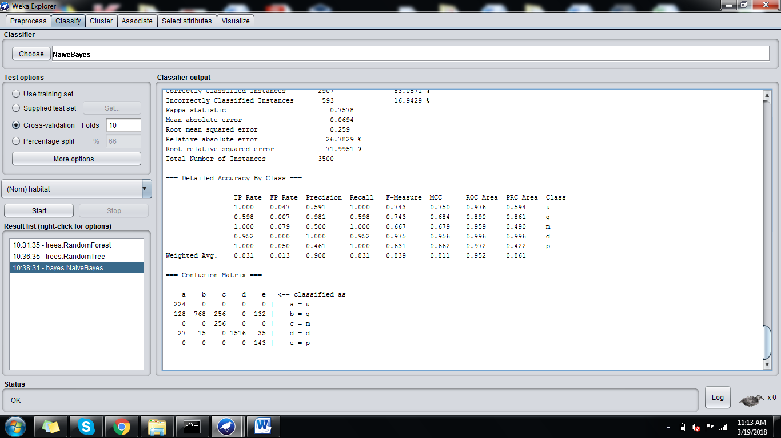

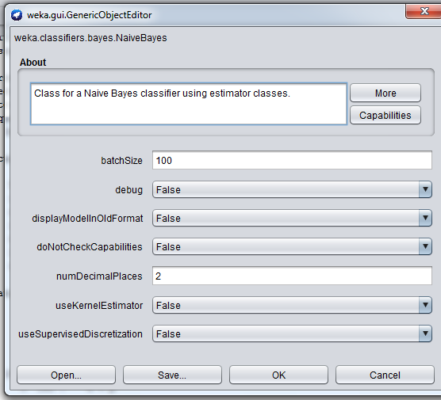

**ADABOOST:**

=== Run information ===

Scheme: weka.classifiers.meta.AdaBoostM1 -P 100 -S 1 -I 10 -W weka.classifiers.trees.DecisionStump

Relation: mushroom1

Instances: 3500

Attributes: 23

class

cap-shape

cap-surface

cap-color

bruises

odor

gill-attachment

gill-spacing

gill-size

gill-color

stalk-shape

stalk-root

stalk-surface-above-ring

stalk-surface-below-ring

stalk-color-above-ring

stalk-color-below-ring

veil-type

veil-color

ring-number

ring-type

spore-print-color

population

habitat

Test mode: 10-fold cross-validation

=== Classifier model (full training set) ===

AdaBoostM1: No boosting possible, one classifier used!

Decision Stump

Classifications

stalk-root = b : d

stalk-root != b : g

stalk-root is missing : d

Class distributions

stalk-root = b

u g m d p

0.0 0.021479713603818614 0.0 0.9504773269689738 0.028042959427207637

stalk-root != b

u g m d p

0.12280701754385964 0.6842105263157895 0.14035087719298245 0.0 0.05263157894736842

stalk-root is missing

u g m d p

0.064 0.3668571428571429 0.07314285714285715 0.4551428571428571 0.040857142857142856

Time taken to build model: 0.15 seconds

=== Stratified cross-validation ===

=== Summary ===

Correctly Classified Instances 2841 81.1714 %

Incorrectly Classified Instances 659 18.8286 %

Kappa statistic 0.6813

Mean absolute error 0.1213

Root mean squared error 0.2463

Relative absolute error 46.8481 %

Root relative squared error 68.4629 %

Total Number of Instances 3500

=== Detailed Accuracy By Class ===

TP Rate FP Rate Precision Recall F-Measure MCC ROC Area PRC Area Class

0.000 0.000 ? 0.000 ? ? 0.752 0.121 u

0.972 0.260 0.684 0.972 0.803 0.687 0.850 0.669 g

0.000 0.000 ? 0.000 ? ? 0.756 0.139 m

1.000 0.044 0.950 1.000 0.975 0.953 0.976 0.945 d

0.000 0.000 ? 0.000 ? ? 0.536 0.044 p

Weighted Avg. 0.812 0.115 ? 0.812 ? ? 0.881 0.695

=== Confusion Matrix ===

a b c d e <-- classified as

0 224 0 0 0 | a = u

0 1248 0 36 0 | b = g

0 256 0 0 0 | c = m

0 0 0 1593 0 | d = d

0 96 0 47 0 | e = p

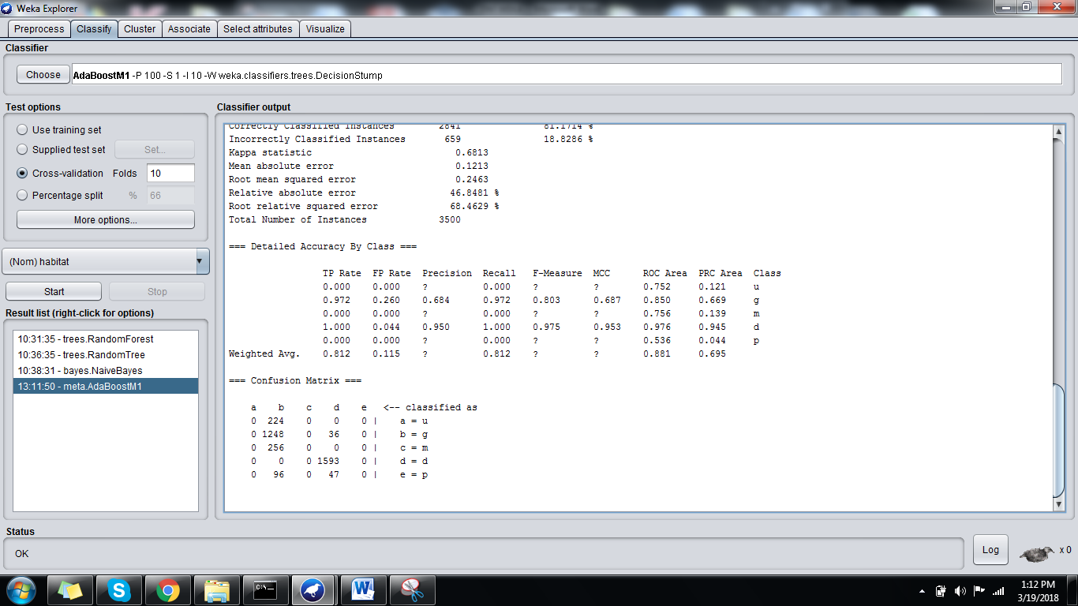

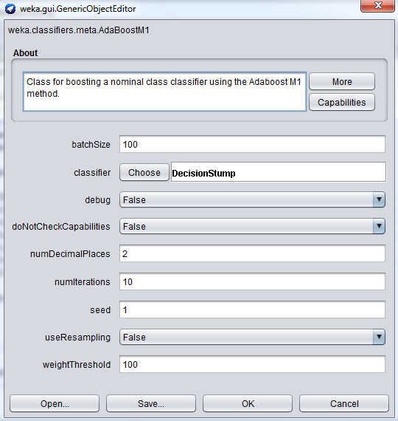

**BAGGING:**

=== Run information ===

Scheme: weka.classifiers.meta.Bagging -P 100 -S 1 -num-slots 1 -I 10 -W weka.classifiers.trees.REPTree -- -M 2 -V 0.001 -N 3 -S 1 -L -1 -I 0.0

Relation: mushroom1

Instances: 3500

Attributes: 23

class

cap-shape

cap-surface

cap-color

bruises

odor

gill-attachment

gill-spacing

gill-size

gill-color

stalk-shape

stalk-root

stalk-surface-above-ring

stalk-surface-below-ring

stalk-color-above-ring

stalk-color-below-ring

veil-type

veil-color

ring-number

ring-type

spore-print-color

population

habitat

Test mode: 10-fold cross-validation

=== Classifier model (full training set) ===

Bagging with 10 iterations and base learner

weka.classifiers.trees.REPTree -M 2 -V 0.001 -N 3 -S 1 -L -1 -I 0.0

Time taken to build model: 0.39 seconds

=== Stratified cross-validation ===

=== Summary ===

Correctly Classified Instances 2652 75.7714 %

Incorrectly Classified Instances 848 24.2286 %

Kappa statistic 0.6281

Mean absolute error 0.0699

Root mean squared error 0.1972

Relative absolute error 26.9762 %

Root relative squared error 54.8029 %

Total Number of Instances 3500

=== Detailed Accuracy By Class ===

TP Rate FP Rate Precision Recall F-Measure MCC ROC Area PRC Area Class

0.580 0.032 0.556 0.580 0.568 0.538 0.981 0.768 u

0.673 0.178 0.686 0.673 0.680 0.497 0.921 0.881 g

0.219 0.064 0.211 0.219 0.215 0.152 0.932 0.327 m

0.979 0.008 0.990 0.979 0.984 0.971 0.999 0.999 d

0.301 0.037 0.257 0.301 0.277 0.245 0.963 0.330 p

Weighted Avg. 0.758 0.077 0.764 0.758 0.761 0.680 0.963 0.865

=== Confusion Matrix ===

a b c d e <-- classified as

130 94 0 0 0 | a = u

104 864 209 7 100 | b = g

0 200 56 0 0 | c = m

0 10 0 1559 24 | d = d

0 91 0 9 43 | e = p

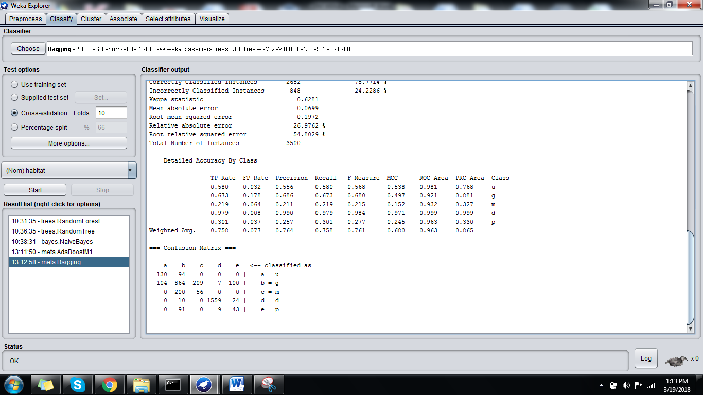

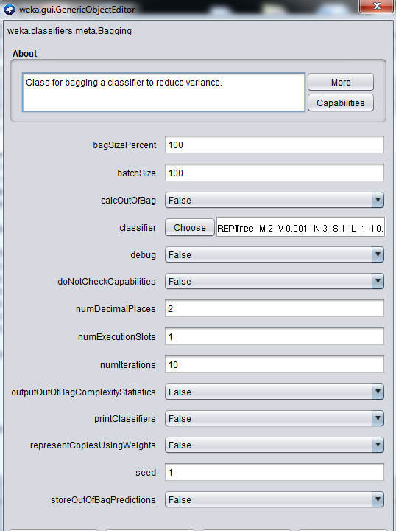

**ASSOCIATIVE RULE MINING:**

GROCERY DATA SET:

SUPERMARKET DATASET INBUILT IN WEKA.

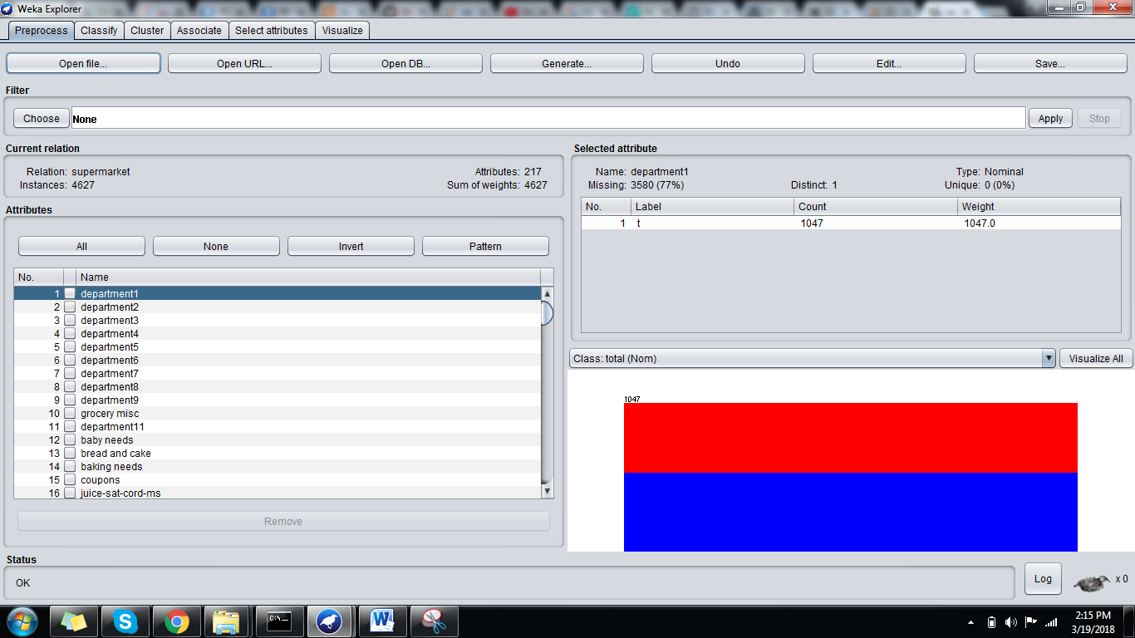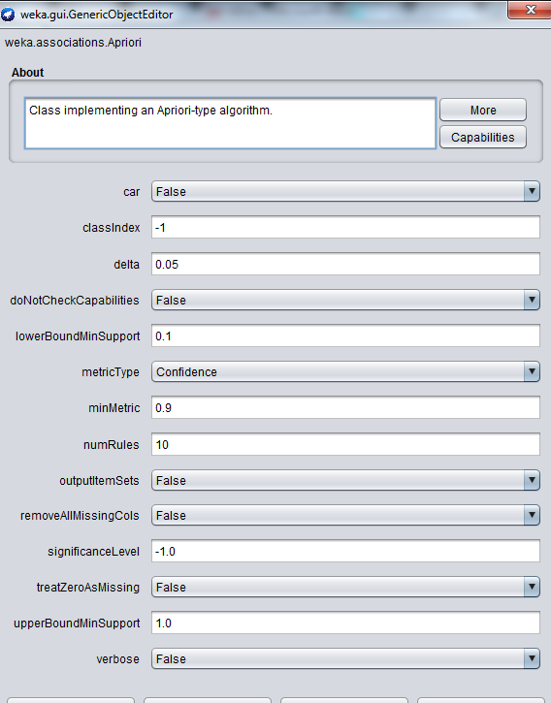

=== Run information ===

Scheme: weka.associations.Apriori -N 10 -T 0 -C 0.9 -D 0.05 -U 1.0 -M 0.1 -S -1.0 -c -1

Relation: supermarket

Instances: 4627

Attributes: 217

[list of attributes omitted]

=== Associator model (full training set) ===

Apriori

=======

Minimum support: 0.15 (694 instances)

Minimum metric <confidence>: 0.9

Number of cycles performed: 17

Generated sets of large itemsets:

Size of set of large itemsets L(1): 44

Size of set of large itemsets L(2): 380

Size of set of large itemsets L(3): 910

Size of set of large itemsets L(4): 633

Size of set of large itemsets L(5): 105

Size of set of large itemsets L(6): 1

Best rules found:

1. biscuits=t frozen foods=t fruit=t total=high 788 ==> bread and cake=t 723 <conf:(0.92)> lift:(1.27) lev:(0.03) [155] conv:(3.35)

2. baking needs=t biscuits=t fruit=t total=high 760 ==> bread and cake=t 696 <conf:(0.92)> lift:(1.27) lev:(0.03) [149] conv:(3.28)

3. baking needs=t frozen foods=t fruit=t total=high 770 ==> bread and cake=t 705 <conf:(0.92)> lift:(1.27) lev:(0.03) [150] conv:(3.27)

4. biscuits=t fruit=t vegetables=t total=high 815 ==> bread and cake=t 746 <conf:(0.92)> lift:(1.27) lev:(0.03) [159] conv:(3.26)

5. party snack foods=t fruit=t total=high 854 ==> bread and cake=t 779 <conf:(0.91)> lift:(1.27) lev:(0.04) [164] conv:(3.15)

6. biscuits=t frozen foods=t vegetables=t total=high 797 ==> bread and cake=t 725 <conf:(0.91)> lift:(1.26) lev:(0.03) [151] conv:(3.06)

7. baking needs=t biscuits=t vegetables=t total=high 772 ==> bread and cake=t 701 <conf:(0.91)> lift:(1.26) lev:(0.03) [145] conv:(3.01)

8. biscuits=t fruit=t total=high 954 ==> bread and cake=t 866 <conf:(0.91)> lift:(1.26) lev:(0.04) [179] conv:(3)

9. frozen foods=t fruit=t vegetables=t total=high 834 ==> bread and cake=t 757 <conf:(0.91)> lift:(1.26) lev:(0.03) [156] conv:(3)

10. frozen foods=t fruit=t total=high 969 ==> bread and cake=t 877 <conf:(0.91)> lift:(1.26) lev:(0.04) [179] conv:(2.92)